Grade Three: Unit 6 Fantastic Adventures with Dragon, Gods, and Giants

Research/information text and informative/explanatory writing

RI.3.5, W.3.6, W.3.7, SL.3.4, L.3.s, L.3.3

[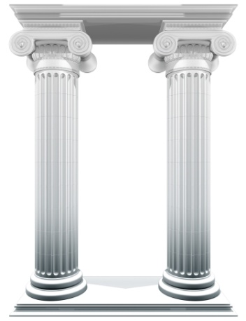](http://www.bbc.co.uk/schools/primaryhistory/ancient_greeks/the_olympic_games/)http://www.bbc.co.uk/schools/primaryhistory/ancient_greeks/the_olympic_games/

<http://ancienthistory.about.com/od/olympics/p/olympicgames.htm>

<http://www.historyforkids.org/learn/greeks/games/olympics.htm>

Very kid friendly language

<http://greece.mrdonn.org/olympics.html>

<http://www.woodlands-junior.kent.sch.uk/homework/greece/sports.htm>

<http://www.thenagain.info/webchron/mediterranean/olympicgames.html>

Games played in Ancient Greece Olympics

<http://www.olympic.org/ancient-olympic-games?tab=The-sports-events>

Games played in 2012 Olympics

<http://www.olympic.org/sports>

<http://www.perseus.tufts.edu/Olympics/>